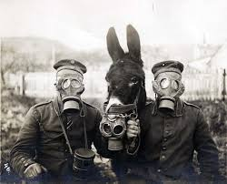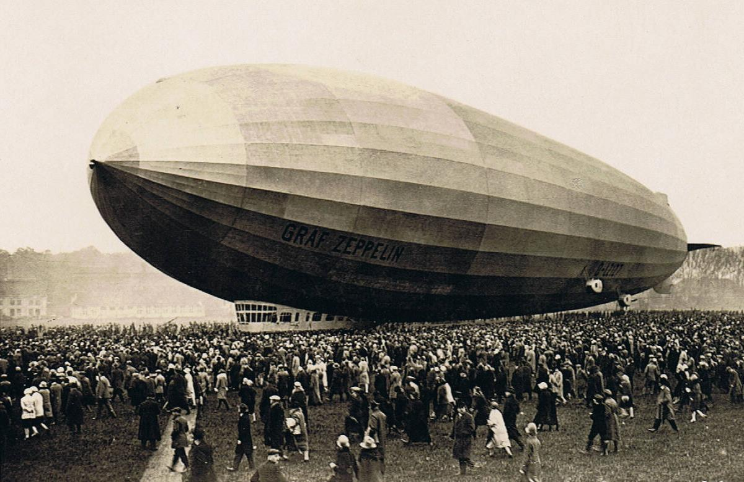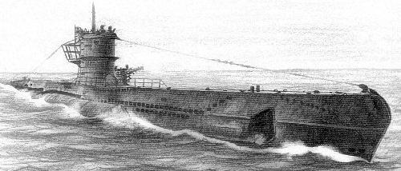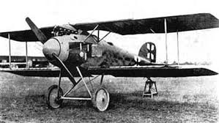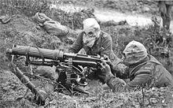

Poison Gas

Poison gas was primarily used to kill entrenched defenders. It caused blindness, and skin rash. Soldiers wore protective masks to defend from the deathly gas. These masks allowed them to hear and talk. The Germans were the first to use this.

Zeppelins

These large gas filled balloons were used by Germany to bomb the English coast. This changed the way of the war because it was easy for multiple people to die.

U-Boats

Germany was the first to use U-Boats in World War 1. These submarines were used for marine warfare during World War 1. This changed the way of the war because now people could fight under water.

Convoys

Convoys are a group of ships sailing together for protection. It was designed to help protect cargo in passenger ships. Britain was the first to use these during World War 1.

Airplane

This World War 1 airplane is equipped with a machine gun. The Germans were the first to use this during the war. This changed the way of the war because now people could fight using aerial warfare.

Automatic Machine Gun

The automatic machine gun was a gun that fired a rapid stream of bullets. This made it possible for one person to kill several people. The British were the first to use this as a weapon during WW1.

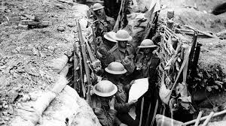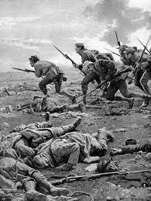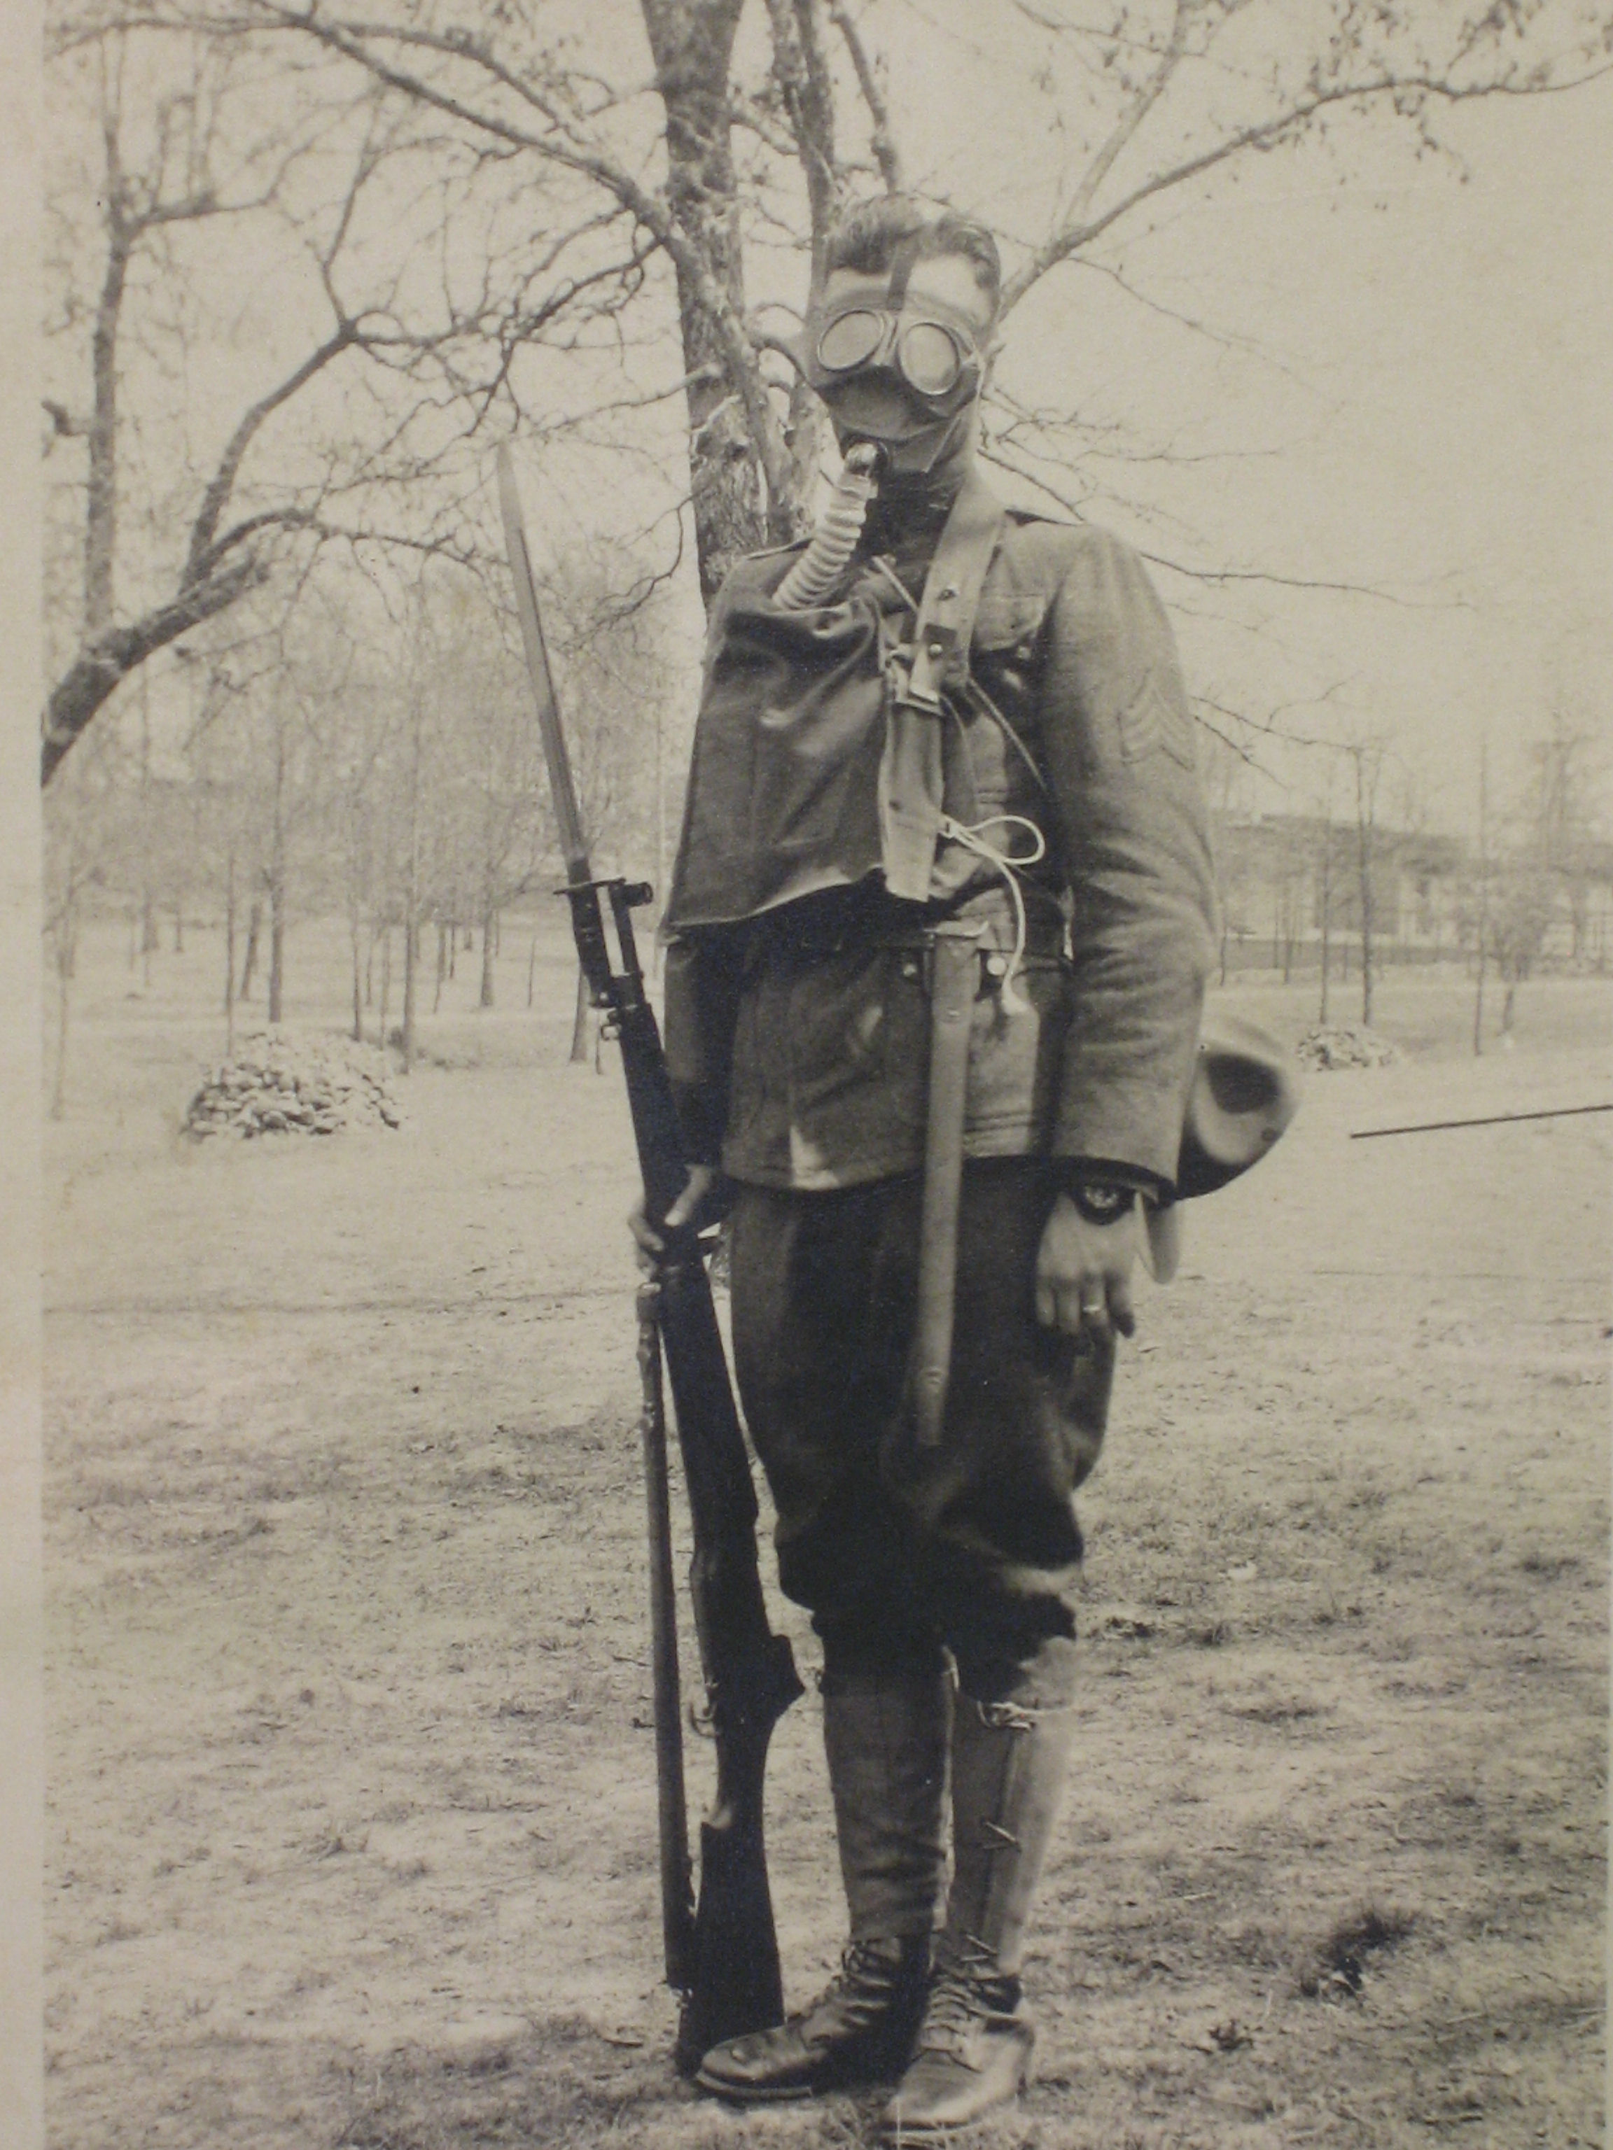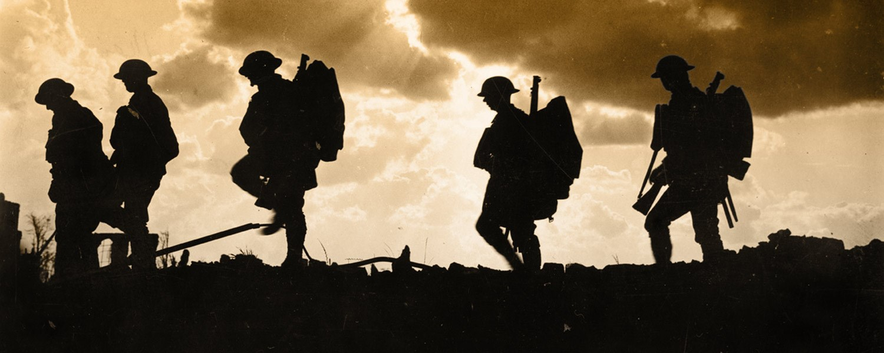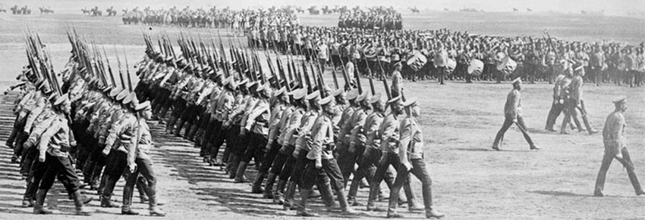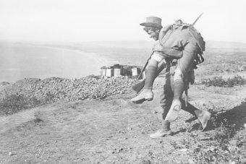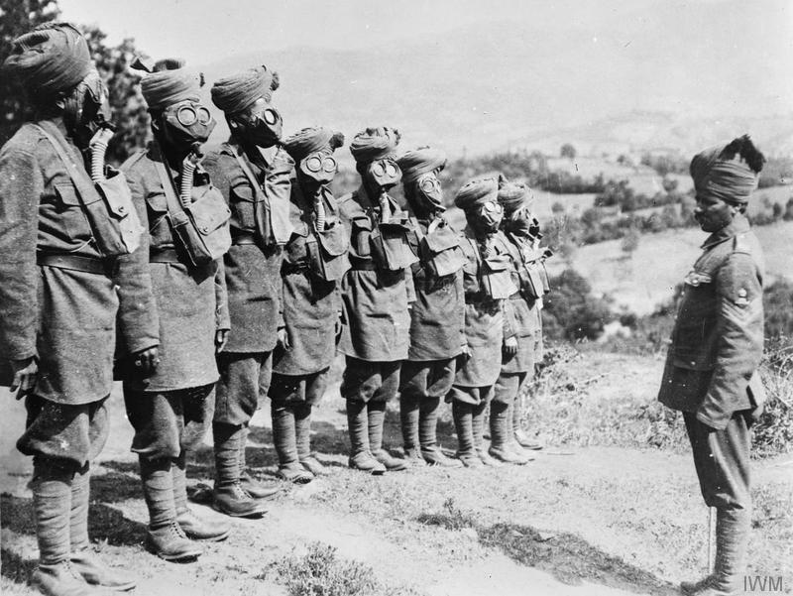

Gracie Muth

WWI Modern Warfare

World History: Connections to Today

Work Cited